**BPP Coursework Cover Sheet**

Please use the table below as your cover sheet for the 1st page of the submission. The sheet should be before the cover/title page of your submission.

|  |  |
| --- | --- |
| Programme | MSc Management |
| Module name | Consultancy Project Proposal |
| Student Reference Number (SRN) | BP0319248 |
| Report/Assignment Title | Summative |
| Date of Submission  *(Please attach the confirmation of any extension received)* | 27 October 2025 |
|  | |
| Declaration of Original Work: | |
| * I hereby declare that I have read and understood BPP’s regulations on plagiarism and that this is my original work, and that I have researched, undertaken, completed and submitted in accordance with the requirements of BPP School of Business. * I declare that where I have used any AI tools, it was for the following reasons (highlight as appropriate):   o To review a draft  o To correct language errors  o Other (please describe)   * I have copied & retained for BPP University’s reference, all AI prompts used in the creation of AI content and all AI-generated responses in support of my assignment and attached relevant evidence in the appendices. * I understand that I may be required to participate in a *viva voce,* where I will be questioned on any aspect of my assignment, including key concepts, theories, examples used, & any sources included. * The word count, excluding contents table, bibliography and appendices, is 1494 words. * **Student Reference Number**: BP0319248 **Date**: 27 October 2025 | |
| By submitting this coursework you agree to all rules and regulations of BPP regarding assessments and awards for programmes. **Please note, submission is your declaration you are fit to sit.**  BPP University reserves the right to use all submitted work for educational purposes and may request that work be published for a wider audience.  **BPP School of Business** | |

**Table of Contents**

List of Abbreviations 4

1 Introduction 5

2 Task 2: Identify the research aim and objectives and provide application of research methodology 5

2.1 Research Aim and Objectives 5

2.2 Research Questions 5

2.3 Research Methodology: 6

3 Task 3: Develop a research plan and explain ethical considerations 6

3.1 Data Collection 6

3.2 Data Analysis 7

3.3 Time Frame 8

3.4 Ethical Considerations 9

3.5 Research Plan 10

4 Task 4: Provide a well-structured proposal addressing the selected challenges 11

4.1 Consumer Engagement and Digital Transition 11

5 Conclusion 11

6 Reference list 13

# List of Abbreviations

|  |  |
| --- | --- |
| **Abbreviation** | **Full Form / Meaning** |
| FDI | Foreign Direct Investment |
| ESG | Environmental, Social, and Governance |
| SDG | Sustainable Development Goals |
| SADC | Southern African Development Community |

# Introduction

Unilever, a global FMCG leader with brands spanning beauty, home care, and food, serves over 3.4 billion consumers across 190+ countries. Despite a 2024 turnover of €60.8 billion and €9.4 billion in operating profit, the company faces challenges from fluctuating volumes, shrinking margins, and rising sustainability demands. External pressures like geopolitical instability, inflation, and shifts toward digital and eco-conscious consumption further strain performance (Hu, and Zeng, 2024). This consultancy project critically examines Unilever’s strategic and operational issues declining profitability, sustainability transition, and digital engagement. Using quantitative methods such as surveys and data modeling, the proposal aims to identify actionable strategies for restoring long-term growth.

# Task 2: Identify the research aim and objectives and provide application of research methodology

## Research Aim and Objectives

**A. Research Aim**

The objectives of the proposed consultancy project are to critically assess the decreasing profitability and operational efficiency of Unilever by quantitatively analyzing the financial and performance indices of the company, with a special focus on sustainability investment and the effectiveness of digital marketing.

**B. Research Objectives**

1. To quantitatively assess the relationship between Unilever’s marketing expenditure and sales growth from 2015–2024.
2. To evaluate the financial implications of Unilever’s sustainability initiatives on profitability and operational costs.
3. To analyse how digital transformation affects Unilever’s market competitiveness and long-term financial resilience.

## Research Questions

1. How does increased marketing and brand investment correlate with sales volume and profitability in Unilever?
2. To what extent has sustainability investment influenced Unilever’s cost efficiency and margins?
3. What is the measurable impact of Unilever’s digital engagement strategies on financial performance?

These questions provide a framework for statistical testing and quantitative modelling using financial and market data derived from Unilever’s reports and primary survey data.

## Research Methodology:

The research design followed in this study is a quantitative research design to investigate the correlation of sustainability, digital transformation, and profitability at Unilever. Both primary and secondary sources will be used to gather data to have an all-inclusive understanding. The primary data will be collected via an organized online questionnaire that shall be administered to 200 Unilever employees and managers working in the marketing, finance, and sustainability departments. The survey will be carried out with the help of a five-point Likert scale to describe opinions on the influence of sustainability practices and digital transformation on profitability. The stratified random sampling method will mean that there is equal representation in the various departments and that there is reduced bias and maximizes accuracy of the results.

The secondary data will be obtained based on the financial reports, sustainability reports, and annual publications of Unilever in the year 2015 to 2024. The analysis of the data will be performed with the help of SPSS and Microsoft Excel with the use of descriptive statistics, correlation, and regression analysis to test hypotheses.

# Task 3: Develop a research plan and explain ethical considerations

## Data Collection

The research proposal will use quantitative research methodology to research the impacts of sustainability and digital transformation on profitability at Unilever. Quantitative research will be suitable since it will enable the conversion of attitudes and performance measures into numerical statistics that can be statistically tested (Mohajan, 2020). The research will utilize secondary and primary data to give a full and valid image.

The primary data will be collected using structured online survey to the Unilever employees and managers in the marketing, sustainability and finance departments. The questions in the survey will be closed-ended with a five-point Likert scale that will enable straightforward measurement of the opinions concerning the connection between sustainability initiatives and profitability. The stratified random sampling technique will be used since 100 respondents are going to be chosen to be representative of all departments and management levels. This increases precision and minimizes bias and thus the results are statistically valid.

The secondary data will be based on the official financial statements, sustainability reports, and annual disclosures of Unilever. These will encompass important points like the level of profitability, investment in marketing as well as sustainability. Triangulation of the two types of data will enhance the validity and suitability of the research, as Ramos, Luiz and Márcia (2020) noted that such a combination of quantitative data and business analytics enhances the quality of performance measurements.

## Data Analysis

The SPSS and Microsoft Excel will be used to analyse the data as they are appropriate in quantitative business research. To begin with, analysis will commence with descriptive statistics as mean, median, and standard deviation to describe the important trends in the data.

Second, the data will be tested with the help of inferential statistics to test the hypothesis about the relationships between profitability, sustainability, and digital transformation. The results of the correlation analysis will be used to determine the degree and direction of the relationship among such variables as sustainability spending, marketing costs, and profit margins. The effect of changes in these factors on the outcomes of profitability will then be predicted using regression models. According to Ramos et al. (2020), these analytical tools are needed, to correlate organizational strategies and quantifiable outcomes, to minimize the subjectivity inherent in most business decisions.

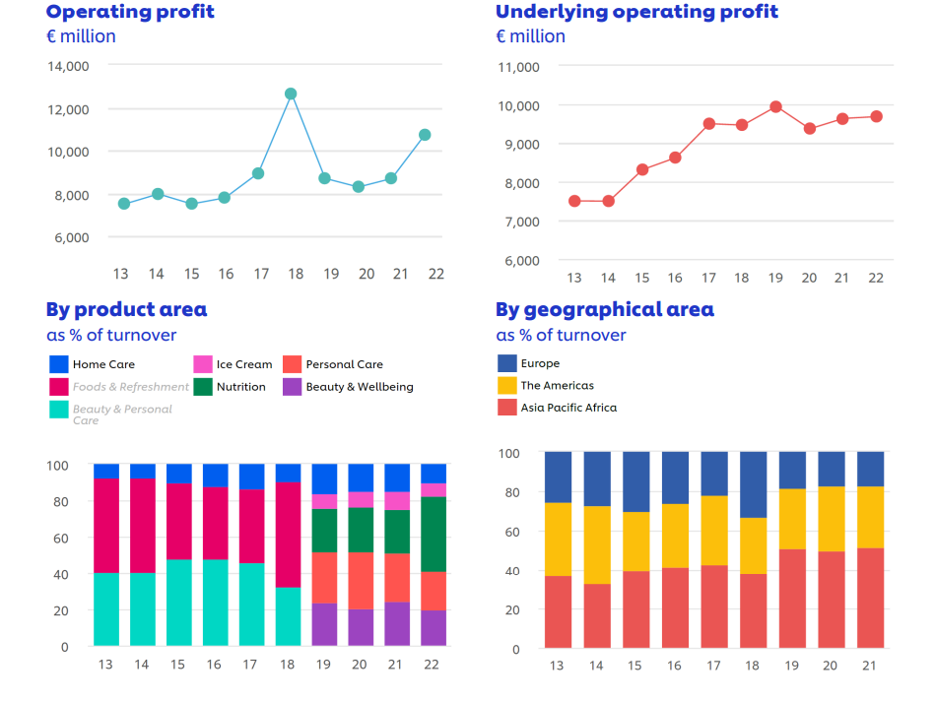

Source:<https://www.unilever.com/files/7b16737e-82ce-45dc-91b3-98a56ffdb5fa/unilever-charts-2013-to-2022.pdf>

T-tests and ANOVA will be used to further delve into the differences between the departments. As illustrated by Yousef (2013), these techniques enable researchers to establish considerable differences and correlations in groups. Lastly, the results will be presented visually in formats of graphs, charts, and tables, in the manner of results presentation at Unilever. This assists in achieving clarity and consistency with the way the company presents performance trends.

## Time Frame

The study will be conducted over eight weeks: two weeks for data collection, three for analysis, two for interpretation, and one for final recommendations.

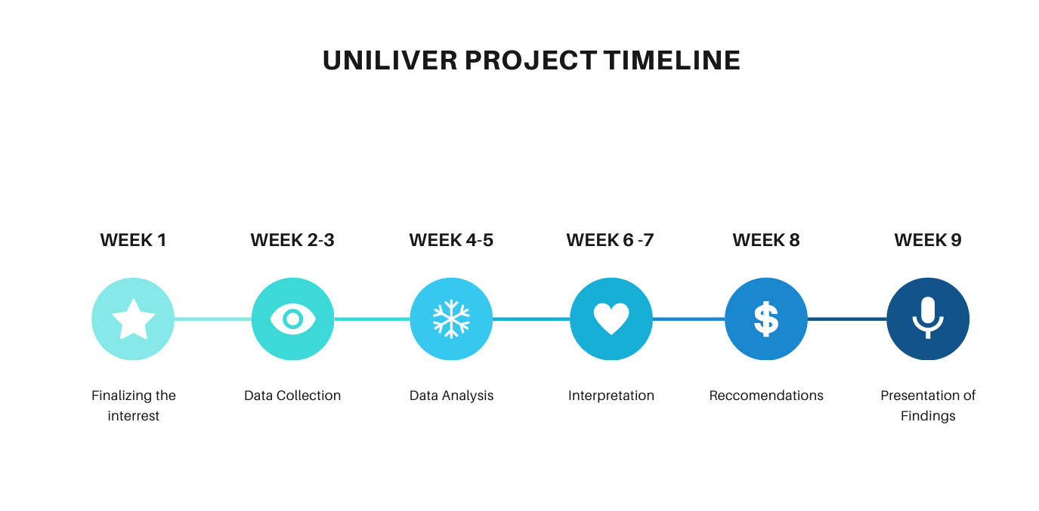

## Ethical Considerations

The ethical integrity of any research to be conducted in a corporate environment is strict. In this paper, the data confidentiality, voluntary respondents, and informed consent will be secured, and the purpose of the research will be properly described, and the respondents will remain anonymous (Powell, 2019). None of the personal financial information belonging to Unilever will be disclosed without permission. The paper shall adhere to the standards of GDPR whereby all personal data shall be stored and anonymized. There should be transparency in data interpretation- it is unethical to manipulate the results to have good results. Objective reporting will be done to give all the statistical outcomes, both in support and contradiction. Ethical norms are applicable to secondary data, which will be referenced accordingly and presented equally.

## Research Plan

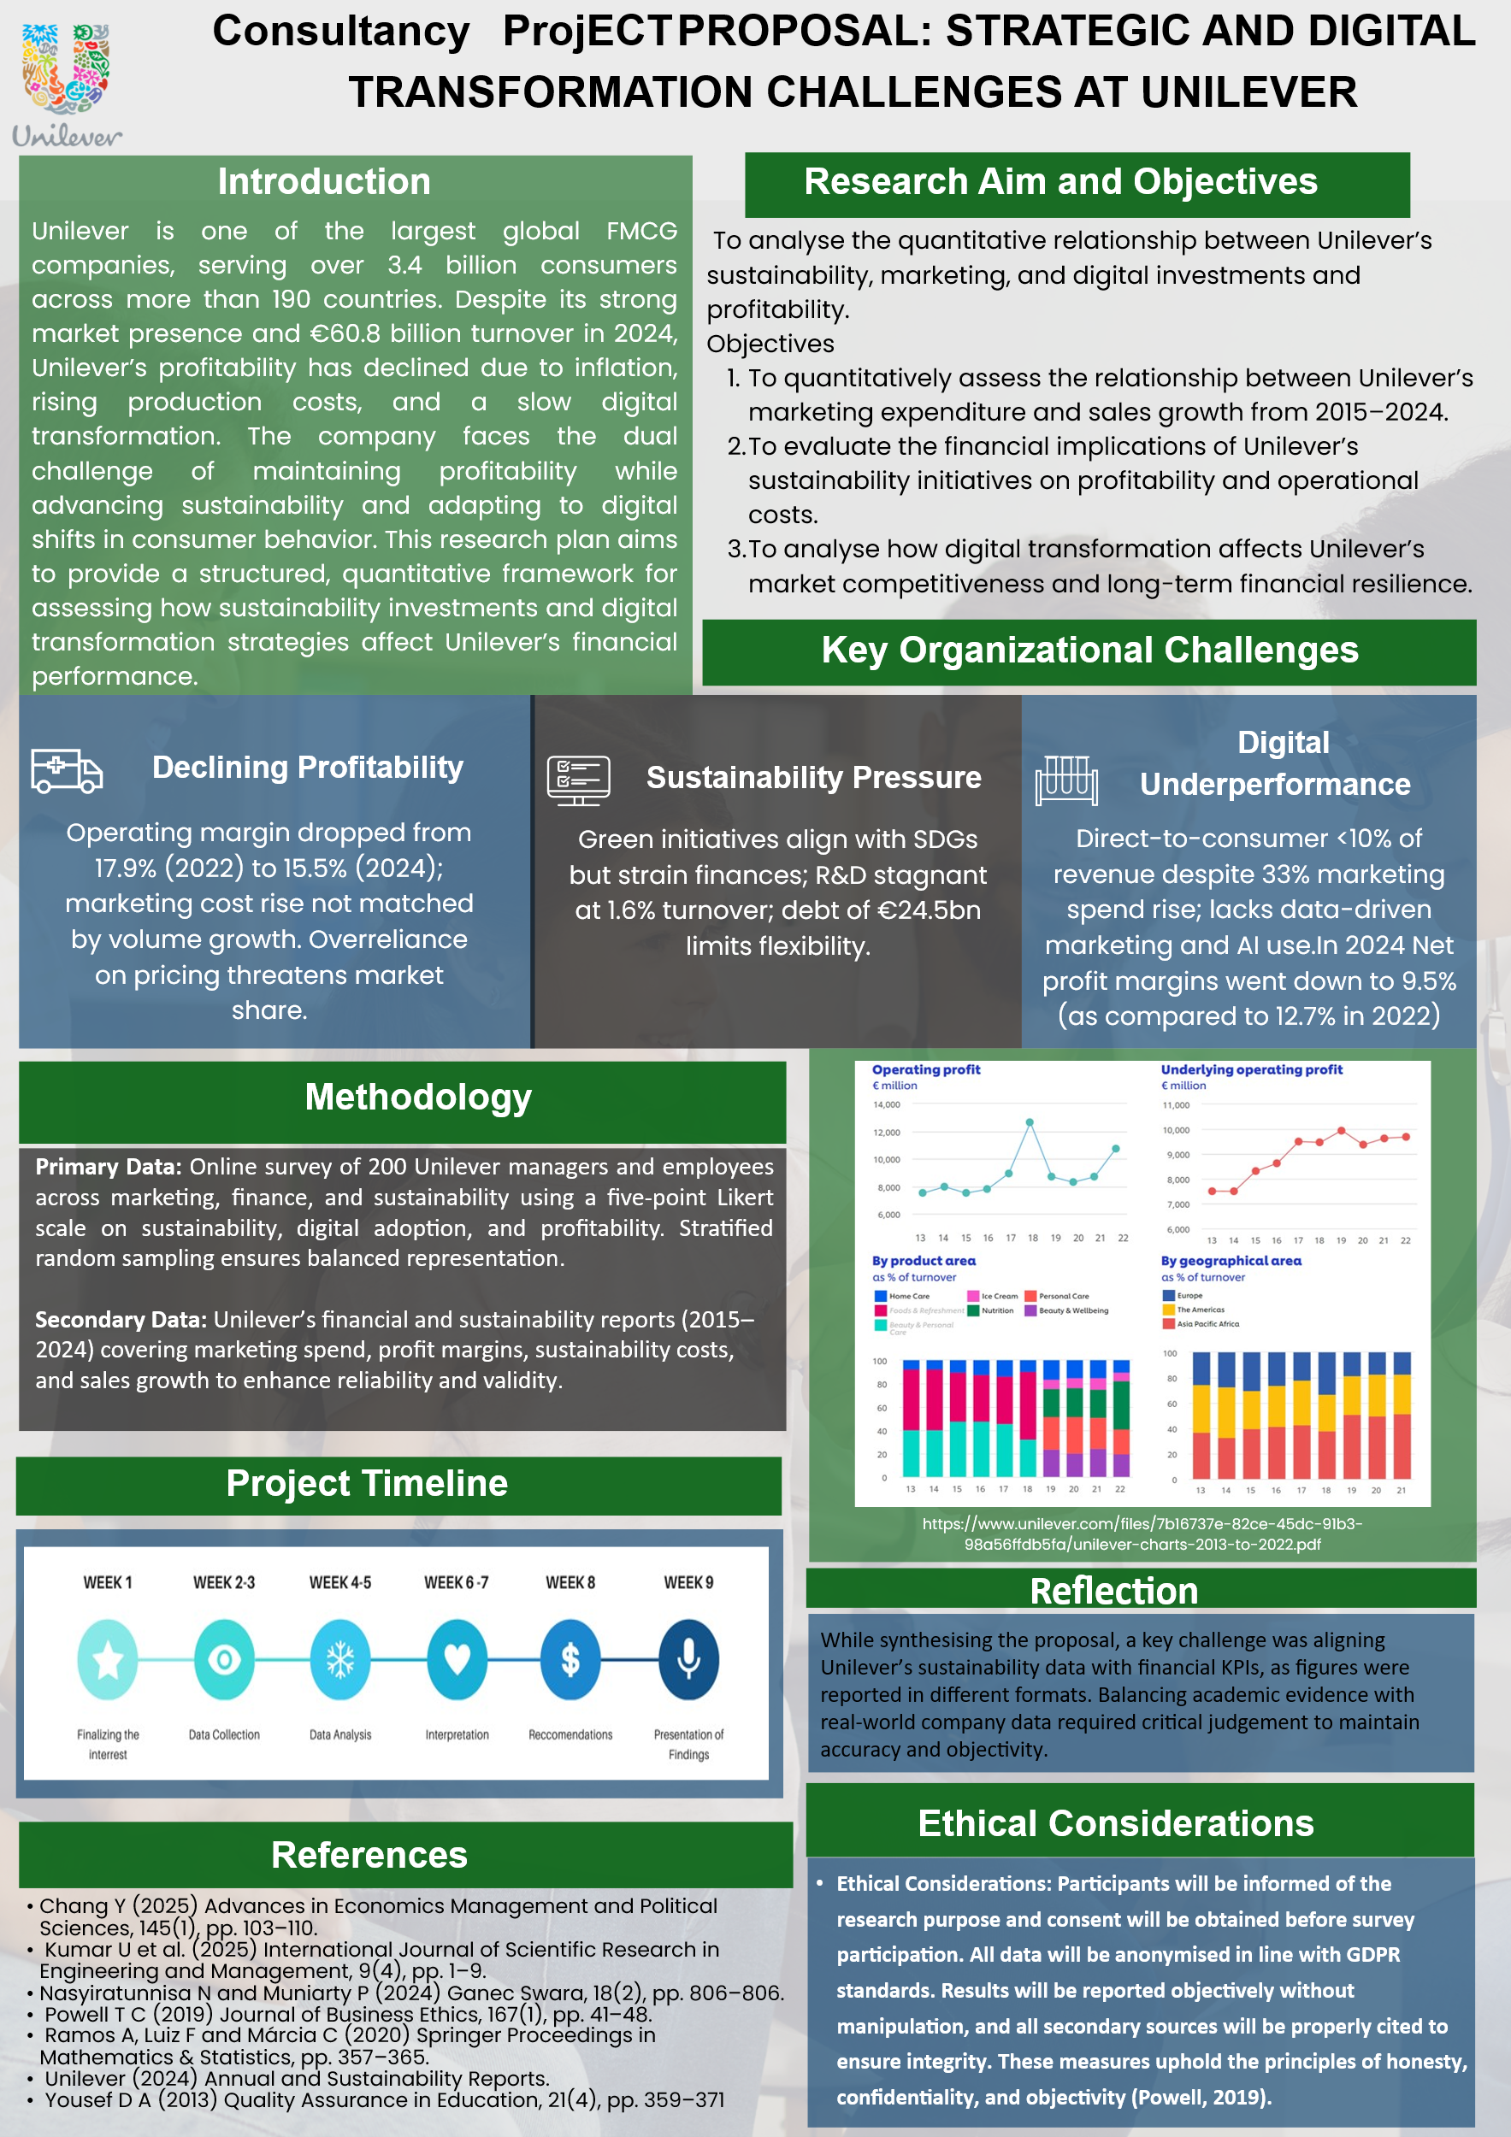

# Task 4: Provide a well-structured proposal addressing the selected challenges

This consultancy proposal incorporates the challenges named above, including diminishing profitability, sustainability inefficiencies, and digital underperformance, by means of a logical quantitative research design. This matching the research aim, objectives and methodology makes sure that every issue is solved by use of measurable evidence. Through statistical analysis of the marketing and sustainability investments of Unilever, the project helps close the divide between operational and strategic decision-making. This well-organized method shows how evidence-based research can help Unilever in achieving profitability and long-term sustainable change.

## Consumer Engagement and Digital Transition

Unilever is failing to cope with the digitization and customer connectivity as consumers are moving online. Although there is a 33% increase in marketing expenditure between 2020 and 2024, direct-to-consumer sales amount to less than 10% of total revenue with poor digital performance. It is a complex organization with a large structure that retards innovation in information-driven marketing and AI personalization and is not as nimble as its rivals such as Procter and Gamble. Kumar et al. (2025) found that predictive analytics, social media marketing, and e-commerce are the technologies used by successful companies in the FMCG to reinstate the engagement and enhance the sales. Competitors, such as Procter & Gamble, have centralized decision-making to incorporate AI-based analytics, but hierarchical Unilever model slows down the shift to data-driven marketing. This organizational sluggishness makes it less responsive to consumer insights, which have a direct effect on customer interaction and profitability. The gap can be resolved by strategically embedding sustainability measures in digital and financial dashboards, which allows making evidence-based decisions to assure the balanced ethical impact and profitability (Chang, 2025).

# Conclusion

The present consulting proposal is an evaluation by quantitative analysis of the financial and strategic challenges facing Unilever. The major challenges are reduced margins, insufficient long-term sustainability investments, and poor digital integration, which pose a threat to competitiveness in the long run. The proposed research will be based on empirical evaluation of the effect of investment allocation on profitability and growth by the financial trend analysis and poll of stakeholders. The results of the findings will point Unilever to information-based strategies that maximize expenditure in sustainability, marketing, and innovation. Through effective statistical procedures, the research will quantify the efficiency and returns on shareholders through targeted investments. Finally, Unilever should use its size and information to create a performance model that would balance profit and sustainability.

# Reference list

Chang, Y. (2025) ‘Comparative Analysis of Investment Opportunities in the Consumer Goods Industry: Procter & Gamble, Unilever, Colgate-Palmolive, and Kimberly-Clark’, *Advances in Economics Management and Political Sciences*, 145(1), pp. 103–110. Available at: <https://doi.org/10.54254/2754-1169/2024.LD19032>.

Hu, Y. and Zeng, Y., 2024. Achieving sustainable operations: challenges, countermeasures, and the case of Unilever. In SHS Web of Conferences (Vol. 181, p. 01036). EDP Sciences. <https://www.shs-conferences.org/articles/shsconf/pdf/2024/01/shsconf_icdeba2023_01036.pdf>

Kumar, U., Kumar, S., Mahajan, A.K., Largotra, P. and Ansari, A. (2025) ‘Leveraging Digital Innovation to Enhance Consumer Engagement and Sales Performance in the FMCG Sector’, *INTERANTIONAL JOURNAL OF SCIENTIFIC RESEARCH IN ENGINEERING AND MANAGEMENT*, 09(04), pp. 1–9. Available at: <https://doi.org/10.55041/ijsrem43390>.

Mohajan, H.K. (2020) ‘Quantitative research: A successful investigation in natural and social sciences’, *Journal of Economic Development, Environment and People*, 9(4), pp. 50–79. Available at: <https://doi.org/10.26458/jedep.v9i4.679>.

NASYIRATUNNISA, N. and MUNIARTY, P. (2024) ‘ANALISIS PERBANDINGAN NET PROFIT MARGIN (NPM) PADA PT UNILEVER INDONESIA,TBK DENGAN PT INDOFOOD SUKSES MAKMUR,TBK’, *GANEC SWARA*, 18(2), pp. 806–806. Available at: <https://doi.org/10.35327/gara.v18i2.862>.

Powell, T.C. (2019) ‘Can Quantitative Research Solve Social Problems? Pragmatism and the Ethics of Social Research’, *Journal of Business Ethics*, 167(1), pp. 41–48. Available at: <https://doi.org/10.1007/s10551-019-04196-7>.

Ramos, A., Luiz, F. and Márcia, C. (2020) ‘Quantitative Approaches for Identification of Indicators and Their Relationships in Performance Measurement Systems: A Literature Review’, *Springer proceedings in mathematics & statistics*, pp. 357–365. Available at: <https://doi.org/10.1007/978-3-030-56920-4_29>.

Yousef, D.A. (2013) ‘Predicting the performance of undergraduate business students in introductory quantitative methods courses’, *Quality Assurance in Education*, 21(4), pp. 359–371. Available at: <https://doi.org/10.1108/qae-11-2012-0043>.